cu park: an application to find availability of parking spaces
By
MOneefa JOnes

A Proposal Submitted in Partial Fulfillment of the Requirements
For the Degree of Bachelor of Science in The
Department of Mathematics and Computer Science

Claflin University

Orangeburg, South Carolina
December 2021

12/09/2021
Shrikant Pawar |  | Karina Liles
Thesis Advisor |  | Committee Member
John Liston |  | Ramier Sriram
Committee Member |  | Academic Advisor

Received by: |  | Date:
Dr. Karina Liles, Interim Chair, Department of Mathematics and Computer Science

Received by: |  | Date:
Dr. Verlie Tisdale, Acting Dean, School of Natural Sciences and Mathematics

Received by: |  | Date:
Dr. Verlie Tisdale, Interim Vice Provost for Academic Affairs

 | PAGE
Acknowledgements | ii
Thesis Statement | iii
Abstract | iv
List of Keywords and Abbreviations | v
List of Tables | vi
List of Figures | vii
Introduction | 1
Background/Literature Review | 3
Methodology | 9
Results | 10
Discussion/Future Work | 12
Conclusion | 13
References | 14
TABLE OF CONTENTS

ACKNOLWEDGEMENTS
A special thanks to every student and staff member for their feedback and participation.
A special thanks to every member of my committee and my thesis advisor for helping, reviewing, and believing in my thesis research.

ii
THESIS STATEMENT
Imagine being able to find a parking space without driving around the parking lot multiple times. I propose a system or application (app) that will allow students and teachers to log onto the app and be notified when and where there is a parking space available. When the user first goes to the app, they will be able to continue as a visitor or login in. Visitors will be given the option to create a login if they wish. There are three types of users, teacher, students, and visitors. Once logged on, the user would be able to click on a diagram of whichever parking lot they were looking to park in and see the actual parking space that is available. Teachers will be able to view reserved spots and all parking that is available for teachers. Students with decals will view the parking lots available to them and students with no decals as well as visitors will see all open parking lots. The parking space would turn green if available, and red if taken.
This app will be called Parking Garage. Each parking space will have a sensor that will be programed to register when a car is in the spot, and send a notification to the app of the available spots. The app might also use cameras to get all 365 views of the parking lots and get real time data. The system will be required to know the difference between student, visitors and teachers. It will also be required to monitor available spots, notify users, and show available spots on map.

ABSTRACT
Through my research and with feedback from students, I propose a mobile application that will allow easy navigation through Claflin’s parking lot.
As Claflin’s student population and community continues to grow, their parking systems are evolving at a slower pace. The problem is there are more students with vehicles transferring and coming to Claflin, than there are parking spaces. Student with a parking pass have limited but better spaces than students without one, but they still often find themselves with no parking, or far parking. Students with no parking passes must park far and often fear getting their vehicle towed if they park incorrectly. Commuter students have it hard as well because when they get ready to come on campus for classes, they find themselves circling the parking lot numerous times. Claflin’s parking system leaves students, visitors, and teachers in distress when looking for a space in a timely manner.

iv
LIST OF KEYWORDS
Ingress: the act of going in or entering
Egress: the act of leaving or exiting

v
LIST OF FIGURES
Question for students…………………………………………………………9-10
Application Prototype Images1-5…………………………………………10

vi
INTRODUCTION
The first parking lot was built around1917. Since then, parking systems have evolved in many ways. Although parking systems continue to change, the problem of finding a parking space in a timely manner still remains a global issue. In Tippecanoe Indiana, the population is about 155,000 and has about 355,00 parking spaces. Along with not having enough spaces, there are cons that come with having an abundance of parking systems. With more parking, there are more pavements being used which leads to more trees having to be cut down. This is ultimately bad for the environment and the planet. Runoff from pavements and cars into rivers and lakes can also pollute the water. Accidents can also be caused in parking lots, if they are congested with traffic or if drivers are distracted. According to national safety council, distracted driving has led to 50,000 crashes causing over 500 deaths and 60,000 injuries. SpadaLawGroup insurances have reported that their research shows over 20% of accidents 14% claims come from distracted driver in parking lots.
In many places parking can be time consuming like those of School parking lots. Although parking cannot determine class size, class size can affect parking. If each year the class sizes grow eventually the number of vehicles per parking space will be greater.
Claflin University is known for its academic excellence and close-knit student community. One problem many students encounter after their freshman year, is finding a good parking space. Like most universities parking is a main problem that many students complain about. 85% of Claflin’s student population drives to school A survey conducted showsthat it takes students anywhere from 10–25 minutes to find a parking space and walk to class. Imagine being able to find a parking space without spending time circling the parking lot. Students with parking decals tend to get the best parking spaces, but not always. Students with no decal often have an easier time parking but usually have to walk much farther. Students with no decal also have the risk of getting their vehicle towed if they park in the wrong spot.
To address above issue, am purposing a mobile (iOS and android) application (app) that will benefit students and other users and help them navigate through Claflin’s parking system easier. The app will be CU Park app: Parking Garage. CU Park will allow students, teachers, and visitors access to available and unavailable parking spots within minutes. Users will be able to sign in or continue as a guest user, once past the login page, users will be able to choose the parking lot they would like to park in. The color codes will be utilized for accessing information quickly, red code for space unavailability, and green for parking space availability. Sensors and cameras will be utilized for monitoring the parking lots and provide real time date feeds.
From student feedbacks, I was able to gather information about what they thought about Claflin’s parking system. I conducted a survey and received responses from 50 students.I was able to identify how long it took many students when parking and the parking lots they thought were the worse. 1
The prototype will display parking lot spaces, so user will be able to visualize their exact parking location. Ultimately, I hope that this app will significantly cut back on the time used when parking.

ARTICLE 1:ILLINOIS STATE University; Parking LOGIX
Illinois State University (ISU) is one of many other schools experiencing parking problems. Instead of not having enough parking, ISU faces the problem of underused parking lots. The author explains that ISU is one of the oldest universities and was founded in 1857. The school realized the underused parking garages by auditing permit sales.
ISU created a parking app that would help make better use of the parking garages. That app is Parking Logix OpenSpace system. This app provides information for how many spots are available in their lots at specific time. Students receive information from the app by display message boards placed at every parking garage entrance. The Parking Logix app uses count sensors that help monitor where and when cars are parked. This app benefits students by allowing them to know the exact number of available spots. It also benefited the parking department by allowing them to handle student complaints better.
Parking Logix gives cost-effective real-time parking counts, statistics, and parking availability. This app was created to help students be aware of the available spaces and to give a cost-efficient solution to their parking. It also allows students to save time when looking for parking. This initiative demonstrates their will to address students complaints and improve their student’s academic experience. From this application, I was able to learn more about ways I can improve parking spot accuracy. I learned that with the use of open space counting the application is able to know the exact number of parking spaces available. This will be a beneficial feature to Cu Park. It will allow students and other users the exact amount of availability.
ARTICLE 2: Students Collaborate and Innovate Parking APP
Loyola Marymount University (LMU), Los Angeles, California understood the difficulties most people experienced when trying to park cars in their campus. To help combat the parking troubles, students at LMU created an app called Rezerv. This app allows drivers to park their cars in the available parking lots of businesses and homeowners. It also allows users to choose a destination for a time period, pay a small fee, and be able to secure a parking spot. Rezerv and business/homeowners receive percentages from these charges.
The idea began as a business idea for an event called startup weekend by Screen. The Rezrv has gone through three performance tests. Through their trials, they were able to learn utilize time management and coding skills to be able to successfully create and build this app. LMU students got opportunity to be in the school while working on its development. The creation of Rezerv has not only benefited students but also regular drivers and event goers.
ARTICLE 3: An App for parking on campus
This article is focused on a parking app from University of California (UC), San Diego. The IT team, and some students from UC San Diego collaborated with Resource Management and Planning team to create a parking feature to the mobile application. The app shows percentage of people parked at specific locations and parking lots on campus.
This app feature was created to help students save time and money when searching for parking. It also displays campus shuttle times. This project provided students real projects outside of a school curriculum. Students can use this experience for future job opportunities. This app presently shows users where students cars are parked and shuttle times, but their team is also working to adding more feature (information on vendors, cafeteria, etc.). This will ensure that all features will be in one place.
From this article, we reach to conclusions of complex nature of these use-cases, starting from collecting datasets from camera hardware to image analysis. Personally, I feel that all schools should implement a project such as this that will allow students to put their knowledge together to improve the school. College would be taken more seriously, and it will give students knowledge to real world application.
ARTICLE 4: East Tennessee State App helps students hunt down parking spots
East Tennessee State University added a feature to their school mobile app to help students find available parking. With the help of three companies (Streetline, Case Parking, and Blackboard Mosaic), the school was able to add this feature.
Streetline contributed to the app with front-end development. Streetline’s tool Parkedge gives a way for users to see the parking counts of the lot. Streetline apps show real time parking availability to users depending on their destination. Case system is used to count cars as they leave and enter. The system then sends information to a hardware device that sends it to the cloud. Blackboard is the school’s mobile platform were the users initially go to access parking information and information about the school. User can download the mobile app from android and apple app stores.
ARTICLE 5:Auburn alumni create campus parking app.
Alumni students from Auburn University understood how annoying it was to find parking at school. The app introduced in this article is called the War Eagle Parking app. This application like many other parking application updates in real time and sends information to students. This app differs from other parking app. It differs because user is allowed to enter their destination and gives directions to available parking in that area. The author talks about how cameras are used to give live steams to the app that helps correctly show unavailable and available spaces. Users can also see how long a car has been parked.
War Eagle Parking App was created to help save time looking for parking. With CU Park, I hope to be able to benefit students and help them save time when looking for parking. The War Eagle Parking App currently monitor 200 parking spaces. Although it monitors 200 spaces, the school would eventually like for it to monitor up to 12,000 spaces. CU Park will be able to monitor all of Claflin’s parking lots. Allowing alumni student to work on and build a parking app, lets them put the knowledge they learned while at the school to use. It also allows students to be able to give back to their school.
Through each of these Articles, I was able to gain more knowledge and information that are beneficial to my proposal. They also gave me insight on how Many different colleges and cities handle their parking problems. With help from their community, alumni, and security officers many were able to come up with a proper solution. In these articles, open space availability, using real time technology, cameras, and front end development was used. I learned how many different solutions were made for one common problem. One city partnered with the community to allow drivers to park in any available driveways or business lots, while another school created an application that allowed users to enter a destination and then receive directions how to get there. Each solution helped me and allowed for different approaches when considering Claflin’s parking.

METHODOLOGY
To gather information about whether this parking app would be successful, I decided to create a survey to determine whether it would be useful at Claflin University. I created this survey using Survey Monkey. In a span of a couple of weeks responses and information about the parking system at Claflin was collected. This app would be for students and teachers to be able to park effectively and in a timely matter. The user classes of the app include;user registration, past search, parking map, availability, teacher, and student/visitor classes. In this survey, I asked which parking lot is the worst to park at, and also the logistics of Claflin’s parking system. Students responded to the questions in a timely matter. Survey Monkey was used to create and collect data for the survey. I used Moqups to create the wireframe for the application.The data would be hosted through Claflin University’s current hosting site. It would be available through Claflin’s website in a subsection under the resources tab. It will be titled Parking. Seeing that Claflin’s current infrastructure can currently hold multiple user request, the feature would have no problem doing the same. It will use the same private server currently available and would store information on the current cloud. User’s information will stay secure how it currently is secure with sites like MyClaflin and Moodle. After talking with Mr. Bernard Wescot of the IT department, I was able to determine how to efficiently recover the cost of deployment. Parking fees would cover the cost necessary to deploy.
Implementation strategy:
The user location can be captured with some of the following techniques:
1)Because each device's cellular ID (identification) is unique, cellular ID (identification) is an important component of geolocation. Even if the mobile device does not have current data, information from cell towers can provide a rough location (Zeng et. al 2020).
2)GPS stands for Global Positioning System, which is a satellite navigation system that delivers information on geolocation and time. The most latest GPS technology provides geolocation data that is accurate to within a few meters. You may now get navigators with GPS coordinates built in (Kiss-Illés et al 2019).
3)Augmented GPS (A-GPS) is a separate system that enhances the overall performance of a GPS positioning system. Kiss-Illés et al. 2019 found that combining the Cell ID and A-GPS results in more precise location tracking that outperforms ordinary GPS.
4)A geo-fence is a virtual barrier within which an app performs a pre-programmed action, which might be simple or sophisticated. The geofencing approach is used by companies like Uber. Similarly, child-monitoring software tracks the movement of young children using an adapted version of geofencing (Wright et. al 2021).
For tracking, the Maps SDK, Maps JavaScript API, Maps Embed API, Maps Static API, or Maps URLs can be utilized. The following distance matrix API, which estimates the distance between waypoints on a map and how long it will take to cover it, can be used to calculate time between points for two cars or two objects. The Google Distance Matrix API works in tandem with the Google Directions API to deliver precise departure and arrival timing predictions (Gips et. al 2020).
Technical details of deployment:
If Claflin servers are not permitted, Amazon Web Server (AWS) is an option. This will necessitate the use of a computer vision model. We can extract important information from pictures and video frames using a CV model. We can recognize and classify photos, as well as locate and localize items in a scene. To develop own CV models, one can use a range of frameworks such as TensorFlow, MXNet, and PyTorch, or you can use a variety of pre-trained models from AWS or third parties such as ISVs (AWS training guide 2021).

AWS EC2 instance deployment cab be done as follows (AWS training guide 2021):
1)Create an AWS Lambda Function: AWS Lambda is a serverless function deployment tool. "Serverless" does not imply that there is no server; rather, it implies that you are unconcerned with the underlying infrastructure for your code and only pay for what you use. This is frequently preferable to provisioning and administering your own machines, which would have been required in the previous phase.
2)Containerize it and deploy it on Kubernetes (EKS): Nowadays, Kubernetes is one of the most popular platforms for managing and growing containerized applications. Kubernetes' declarative approach aids in the automation of numerous production-level concerns including load balancing and autoscaling.
3)Use Elastic Container Service (ECS) to containerize and deploy app: ECS is a container orchestration service for launching applications, similar to Kuberenetes. The distinction is in the way responsibilities are distributed. Instead of the user being responsible for the lower-level infrastructure problems that Kubernetes would require, you have AWS take care of them for you. In the same manner that Lambda abstracts away infrastructure issues, ECS does the same. In terms of versatility, it falls in between Lambda and Kubernetes.
Deployment specifications can be as follows (AWS training guide 2021):
Amazon EC2 instances pre-installed with popular deep learning frameworks and interfaces such as TensorFlow, PyTorch, Apache MXNet, Chainer, Gluon, Horovod, and Keras to train sophisticated, custom AI models, experiment with new algorithms, or to learn new skills and techniques.

Handling multiple requests:
These can be addressed with following 3 techniques:
1) Static Anycast IPv4 addresses: This allows client programs to retry if one of their IP addresses becomes unavailable due to network outages. Users can now make changes to application architecture behind the scenes without needing to update DNS records or client applications thanks to static IP addresses (Woodcock et. al 1996).
2)AWS global network and performance routing: When a request is sent to a Global Accelerator IP address, it enters the AWS network via an edge site near the end user before being routed to the most appropriate AWS Region via the AWS global network. TCP or UDP internet traffic from your customers is directed to your applications running on Network Load Balancers, Application Load Balancers, and Elastic IP addresses in AWS Regions over a congestion-free global network provided by AWS. This eliminates the inconsistency of routing traffic over the public internet, which can improve performance for latency-sensitive applications such as APIs and video/voice over IP use cases (AWS training guide 2021).
3) When a Global Accelerator is provisioned in front of multiple AWS Regions, requests are routed by default to the Region closest to the user's end to give the best performance. Global Accelerator provides traffic dials to move traffic between the Regions specified behind the accelerator to alter how traffic is routed. When one need to reroute traffic from a Region that has reached its capacity limit, take a Region offline for maintenance, or gradually ramp up traffic for a newly added Region, these traffic dials come in handy. Users can use Global Accelerator's endpoint weights to balance traffic between Network Load Balancers, Application Load Balancers, or Elastic IPs for even finer grained control of Regions comprising many endpoints. When performing A/B testing or blue/green deployments, weighted endpoints can assist in the rollout of new application modifications (Cisco 2021).
App development using android studio:
Following can be some classes for developing this app
- Create CarAppService and Session
- Create start screen
- The CarContext class
- Implement screen navigation
- Interact with the user
- Display notifications
- Request permissions
- Car Hardware APIs
- The lifecycles of a CarAppService and a Session
Special security protocols:
The most common security concern for an application on Android is whether the data that user save on the device is accessible to other apps. There are three fundamental ways to save data on the device: Internal storage, External storage, Content providers. The security protocols can be implemented using following 3 ways:
1)Using cryptography: In addition to providing data isolation, supporting full-filesystem encryption, and providing secure communications channels, Android provides a wide array of algorithms for protecting data using cryptography (Schlosberg et. al 2016).
2)Using interprocess communication: Some apps attempt to implement IPC using traditional Linux techniques such as network sockets and shared files. However, you should instead use Android system functionality for IPC such as Intent, Binder or Messenger with a Service, and BroadcastReceiver (Fernandez et. al 2019).
3)Using binder and messenger interfaces: Using Binder or Messenger is the preferred mechanism for RPC-style IPC in Android. They provide a well-defined interface that enables mutual authentication of the endpoints, if required (Kock et. al 2014).
3)Security in native code: In general, this should use the Android SDK for application development, rather than using native code with the Android NDK. Applications built with native code are more complex, less portable, and more like to include common memory-corruption errors such as buffer overflows (Kock et. al 2014).
RESULTS
To gather feedback and information I asked 50 students questions to determine how they felt about Claflin’s current parking system and which parking lot they felt needed work on. Some sample questions used were as follows:
1. Do you find Claflin’s Parking system to be a nuisance and time consuming?
2. If a parking app was created, would you use it?
3. Which parking lot is the worst?
4. How long does it usually take to find a parking space between class?
5. Do you have any parking suggestions where Claflin should put a parking lot?
The Charts below shows the results to the questions asked:

APPLICATION PROTOTYPE
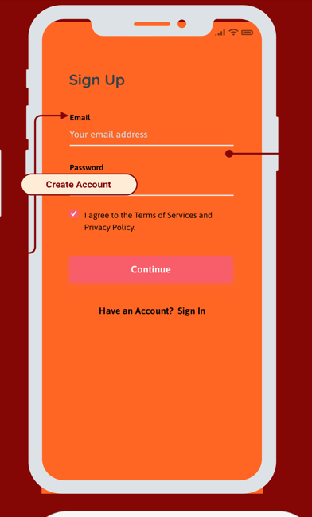
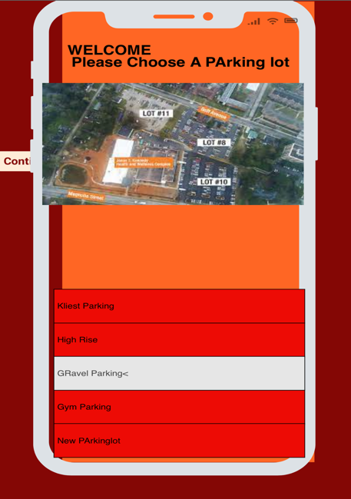
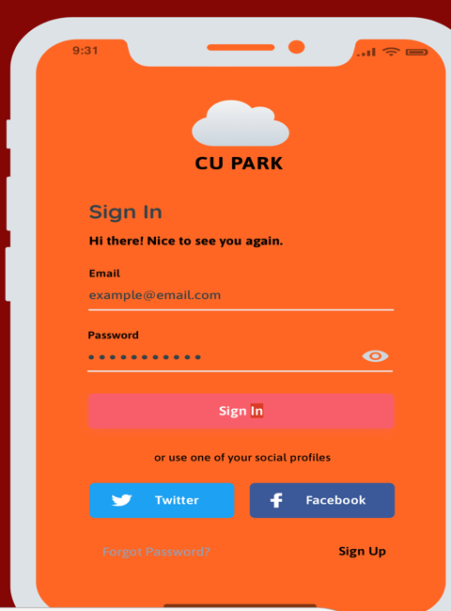
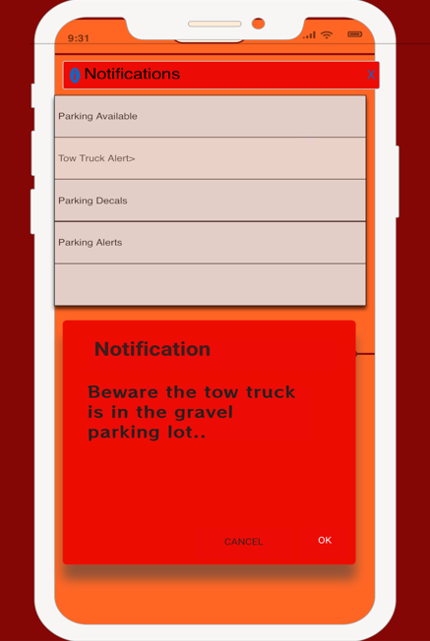
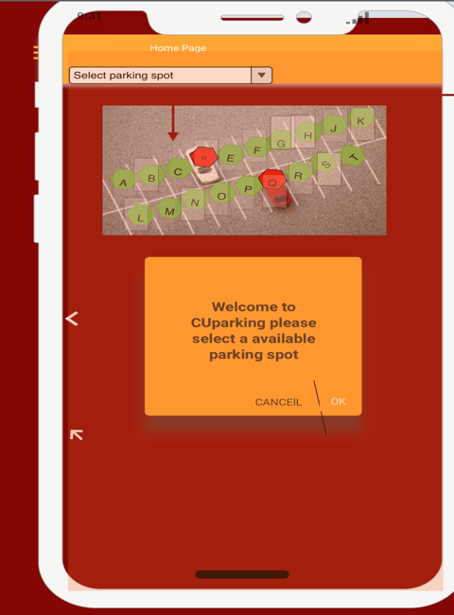

FUTURE WORK
In future, I hope to implement and add additional use-cases to this app. I hope to add a way for teachers with reserved spots to receive special notifications regarding that spot. I also hope to implement weatherproof sensors and a way for the user to be able to be navigated to the spot by a global positioning system. This app will not only be for Claflin students but for other students at other universities including South Carolina State University.. I have hopes that a version of my application will be available on apple and android for download. I hope to actually code and build this app or a prototype. Some interesting features like that of sending notifications to users when the tow truck is in the parking lot would be extremely beneficial.
Limitations of current study
Upon completing my and reviewing my research, I found there were many additions and changes that could be made that would be beneficial. Given more time, I would get a larger quantity of responses for the survey. I realized that a survey size of 50 is not sufficient enough for a school population that if greater than that. Another limitation would be not finding an efficient cost analysis. With more time I would look into how many of the 2000 students would actually use it and if it would be worth it. I would also need to know how much it would cost to add the parking feature to the website and the cost of the sensors needed. Talking with the department of security would be necessary to get data about the percentage of students that have decals. They would also need to be contacted the student, teacher,and visitor population and usage of the parking lots.

CONCLUSION
Claflin University’s parking takes most students anywhere between 10-20 minutes or more to find a suitable space. It takes students numerous rides around the parking lots before finding parking. When parking is found it is usually far, or a person is almost late for class. As Claflin’ community continues to grow, I think it is imperative that the parking systems grow with it.
To conclude, I am purposing an application that will benefit Claflin and help improve their parking. The application will be called CU Park: Parking Garage. This application will be able to show users available and unavailable parking paces in each one of Claflin’s main parking lots. If a space is occupied, it will turn red and if a space is available, it will turn green. Users will be able to receive notifications and real time data feeds. Users will also be able to choose the parking lots they would like to park in, and the app will show diagrams of each parking lot and space.
With feedback receive from students I was able to know which one of the lots were considered the worst and suggestions on where a new parking lot should be built. I was also able to research how much time it took the average student for parking their cars. Many students feel that the current parking system is time consuming and could use some improvements. CU Park will be a mobile based app and will eventually be able to be downloaded from apple and google play store. CU Park will help ensure students have a easier time parking as they get to class on time.

References
- Chen, J. G. and L. (2019, March 7). Parking on campus? there's an app for that! Parking on Campus? There's an App for That! Retrieved November 10, 2021, from https://ucsdnews.ucsd.edu/feature/parking-on-campus-theres-an-app-for-that.
- Google. (n.d.). Is there a worldwide parking problem? Google. Retrieved November 22, 2021, from https://www.google.com/amp/s/www.bbc.com/news/magazine-17271118.amp.
- Hudson, B. A. (1970, January 12). Auburn alums Create Campus Parking App. CR80News. Retrieved November 10, 2021, from https://www.cr80news.com/news-item/auburn-alums-create-campus-parking-app/.
- Logix, P. (2021, February 24). Illinois State University. Parking Logix - Intuitive Parking Counting. Retrieved November 10, 2021, from https://parkinglogix.com/illinois-state-university/.
- Parking lot accidents: More common and dangerous than you think. Spada Law Group LLC. (n.d.). Retrieved November 22, 2021, from https://www.spadalawgroup.com/blog/parking-lot-accidents-more-common-and-dangerous-than-you-think.cfm.
- Schaffhauser08/14/14, D. (n.d.). East Tennessee State app helps students hunt down parking spots. Campus Technology. Retrieved November 10, 2021, from https://campustechnology.com/articles/2014/08/14/east-tennessee-state-app-helps-students-hunt-down-parking-spots.aspx.
- University, L. M. (n.d.). Students collaborate and innovate to Launch Parking App. Students Collaborate and Innovate to Launch Parking App - Loyola Marymount University. Retrieved November 10, 2021, from https://www.lmu.edu/thelmuexperience/studentscollaborateandinnovatetolaunchparkingapp/.
- Wallace, O. (2021, February 26). Why are parking lots bad for the environment? All Things Nature. Retrieved November 22, 2021, from https://www.allthingsnature.org/why-are-parking-lots-bad-for-the-environment.htm.
- Zeng, G., Gao, J., Shekhtman, L., Guo, S., Lv, W., Wu, J., Liu, H., Levy, O., Li, D., Gao, Z., Stanley, H. E., & Havlin, S. (2020). Multiple metastable network states in urban traffic. Proceedings of the National Academy of Sciences of the United States of America, 117(30), 17528–17534.
- Kiss-Illés, D., Barrado, C., & Salamí, E. (2019). GPS-SLAM: An Augmentation of the ORB-SLAM Algorithm. Sensors (Basel, Switzerland), 19(22), 4973. https://doi.org/10.3390/s19224973
- Wright, W. G., Rafferty, A. P., Winterbauer, N., Locklear, K., & Tucker-McLaughlin, M. (2021). Geofencing: Mobile Technology as a Health Promotion Tool to Raise Awareness of a Dental Clinic in Rural North Carolina. The Journal of rural health : official journal of the American Rural Health Association and the National Rural Health Care Association, 37(3), 667–674. https://doi.org/10.1111/jrh.12501
- Gips, J., Psoter, K. J., & Sufrin, C. (2020). Does distance decrease healthcare options for pregnant, incarcerated people? Mapping the distance between abortion providers and prisons. Contraception, 101(4), 266–272. https://doi.org/10.1016/j.contraception.2020.01.005
- AWS training guide. (2021). Retrieved from: https://aws.amazon.com/training/
- Woodcock, Bill (June 1996). "Best Practices in Anycast Routing" (PDF). Packet Clearing House.
- "Understanding Direct-Inward-Dial (DID) on IOS Voice Digital (T1/E1) Interfaces". (2021). Cisco. Retrieved from: https://www.cisco.com/c/en/us/support/docs/voice/digital-ccs/14072-direct-inward-dial.html
- Schlosberg A. (2016). Data security in genomics: A review of Australian privacy requirements and their relation to cryptography in data storage. Journal of pathology informatics, 7, 6. https://doi.org/10.4103/2153-3539.175793
- Fernandez-Musoles, C., Coca, D., & Richmond, P. (2019). Communication Sparsity in Distributed Spiking Neural Network Simulations to Improve Scalability. Frontiers in neuroinformatics, 13, 19. https://doi.org/10.3389/fninf.2019.00019
- Kock, A. K., Andersen, B., Handels, H., & Ingenerf, J. (2014). Rule-based interface generation on mobile devices for structured documentation. Studies in health technology and informatics, 205, 313–317.

