Establishing a Virtual Classroom

Alote Jones Jr
Department of Computer Science, Claflin University
CSCI 391: Junior Seminar
Dr. Shrikant Pawar
November 21, 2022

Abstract
Education has seen considerable technological developments in the recent several decades, including computer-aided learning, which promises to dramatically alter the ways of teaching and learning. The Internet has played a significant role in the storing and diffusion of information in the educational sector. Traditional classroom-based education entails the speaker delivering course materials in a certain location at a specific time. As a result, both the teacher and the learner are constrained in terms of time and location. Because of the human aspect inherent in the conventional classroom technique, the professor might not always be able to exert maximum effort in planning and coordinating course contents.

Keywords: Education , Computer aided learning, and Technological development

Method
The research method I will choose is a focus group. I will gather a small number of individuals to discuss things in a controlled environment about the benefits of establishing a virtual classroom. I selected this method because I want genuine, uncensored comments to the issue at hand. The questions on the subject are based on thoughts or experiences and therefore cannot be quickly answered with yeah or no.

Introduction

Establishing a virtual classroom allows you to choose your own itinerary much more freely. Courses will be arranged at specified times of the day, and your calendar will be built around class availability. For example, if a student is required to supervise their siblings throughout the day, he may benefit academically by working later at night. It might be challenging to handle a course load in addition to your work commitments if you are presently employed and classes are not accessible after your working hours. Having more control over your schedule also makes it simpler to avoid distractions. This means you may study whenever it is convenient for you. A teacher, for example, may publish homework online on Sundays so that students can do it at their own leisure during the week. For instance, if a kid is needed to oversee his or her siblings throughout the school day, he or she may profit from working later at night. Students may learn how to handle their responsibilities, such as their career/job, bills, housework, and children, if they have any. You may learn in whatever location you like, such as a gym, a coffee shop, or a library. This strategy benefits students who enjoy routines such as working out, practicing, and so on, as long as they are not harmful.
Body
Education can be expensive, but online learning can help students save money in a variety of ways. Students can also save money on transportation by not driving to school. The average student spends more than $1,200 per year on textbooks and course materials. Less money is spent on textbooks since virtual resources are regularly used in classes. Instructional techniques are kept online in a single database where they can be downloaded quickly, allowing for fast adjustments to meet any changes. Room and board rates for off-campus and on-campus students range from $7,500 to $11,000 per year.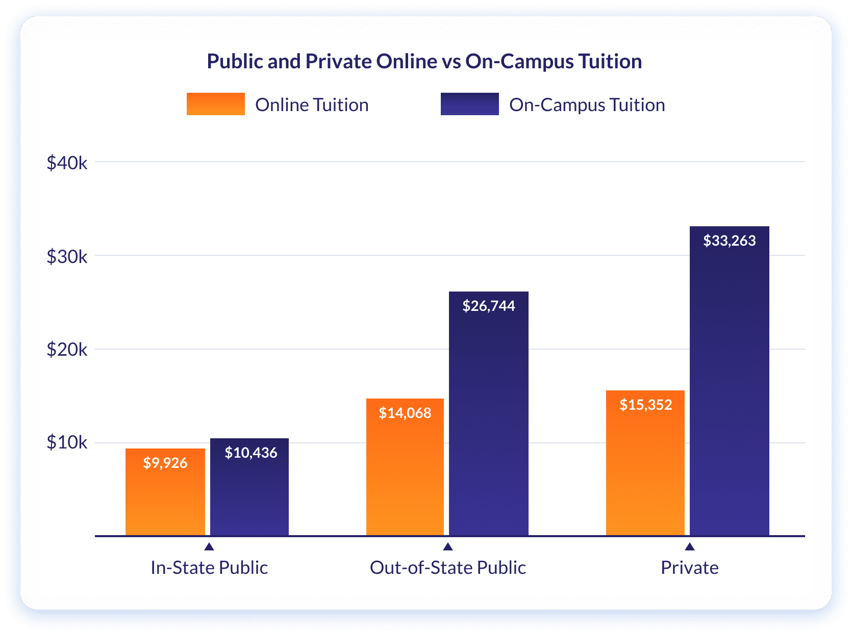
This graph shows that building a virtual classroom is far less expensive than establishing a regular classroom. Tuition and fees at private universities are often greater than at public institutions, leading many students to assume they can only finance one type of learning. For a variety of reasons, academic institutions that offer online courses are often less expensive than traditional campuses. Many colleges that focus primarily on providing online degrees have minimal fees to invest. This allows you more time to do things like travel to new locations, learn how to develop your own company/brand, and do errands because your schedule isn't restricted by classes. You save time by not having to commute to and from campus. This pertains to my following subtopic, cost-cutting measures. You simply need a digital device and an internet connection to have access to the resources you need to further your education and earn your degree on your own time.
Many instructors were compelled to reconsider how to keep kids interested throughout the covid pandemic. Because many school districts shared virtual curriculum during the remote learning time, older students may take more rigorous or intriguing courses than they could in person, according to Rossen. The same may be said for younger students: According to Megan Hibbard, a fifth-grade teacher in White Bear Lake, Minnesota, said many of her students preferred internet learning over in-person learning because they could work on projects that matched their interests.
According to zoom statistics (2022), “ In 2020, people downloaded the video meeting platform about 485 million times. Zoom hosted a bit over 3.3 trillion annual minutes in 2020. In 2020, there were around 350 million daily active participants. 36.59% of all Zoom users are from the US.”
According to Stephen Becker, PhD, a pediatric psychologist at Cincinnati Children's Hospital Medical Center, some parents may have become aware of their children's behavior or learning needs for the first time, prompting them to consider assessment and Individualized Education Program (IEP) services. According to Gehlbach, parents are learning how they may better collaborate with schools to guarantee their children's well-being and academic achievement. According to Scott Graves, PhD, an assistant professor of educational studies at The Ohio State University and a member of the APA's Coalition for Psychology in Schools and Education, parental and teacher monitoring in remote learning likely had a role in lowering bullying.
Students need to manage their time wisely to ensure they complete their assignments by the deadlines set by the professor. Deadlines enable us to cooperate toward a common objective and keep complicated, multilevel projects on track. To establish expectations. Deadlines specify what and when we are expected to deliver. This implies that we take charge of our task without being confused. Immediate feedback is when information is delivered contextually and on-demand, it is in direct reaction to a learner's behavior and in the flow of learning. Instead of waiting days or weeks following examinations, you may frequently obtain rapid feedback. Allows you to address a problem straight away. You can quickly see where you did well and where you need improvement.
As a result, you must be a self-directed learner. If you want to enroll in an online program, you should be aware that these virtual courses demand more self-motivation and self-discipline. You must be self-motivated because your lecturers will not intervene or push you to complete your daily class on time. Every day, you must discover efficient strategies to keep the drive alive. This internal transformation, however, takes time to occur, which is completely natural. All you need to do is be willing to change.
Conclusion
In conclusion, both students and educators benefit greatly from online learning. Students can readily locate textbooks and school resources, as well as employ multimedia to make their learning experience more enjoyable and appealing. Instructors, on the other hand, may distribute assignments and reading materials with a single click utilizing various online platforms that are specifically created to make the teaching and learning process easier and more enjoyable

References
Micah Castelo (2022). How to set up a virtual classroom. Technology Solutions That Drive Education. Retrieved November 22, 2022, from https://edtechmagazine.com/k12/article/2020/08/how-set-virtual-classroom
Kern, A. (2020). Creating an inclusive virtual classroom. Edutopia. https://www.edutopia.org/article/creating-inclusive-virtual-classroom
Alex Sam. (2021). What is a virtual classroom and why is it the future of online learning? eLearning Industry. https://elearningindustry.com/virtual-classroom-why-future-online-learning
American Psychological Association. (n.d.). Capturing the benefits of remote learning. Monitor on Psychology.https://www.apa.org/monitor/2021/09/cover-remote-learning
Zoom revenue and usage statistics (2022). Business of Apps. https://www.businessofapps.com/data/zoom-statistics/

